**Install Docker**

**1. Check Linux version**

There is a minimum kernel requirements for Docker. It must be at least version [3.10](https://docs.docker.com/engine/installation/linux/docker-ce/binaries/). To find out the kernel version, use:

Shell



|  |  |
| --- | --- |
| 1 | uname -a |

or

Shell



|  |  |
| --- | --- |
| 1 | uname -r |

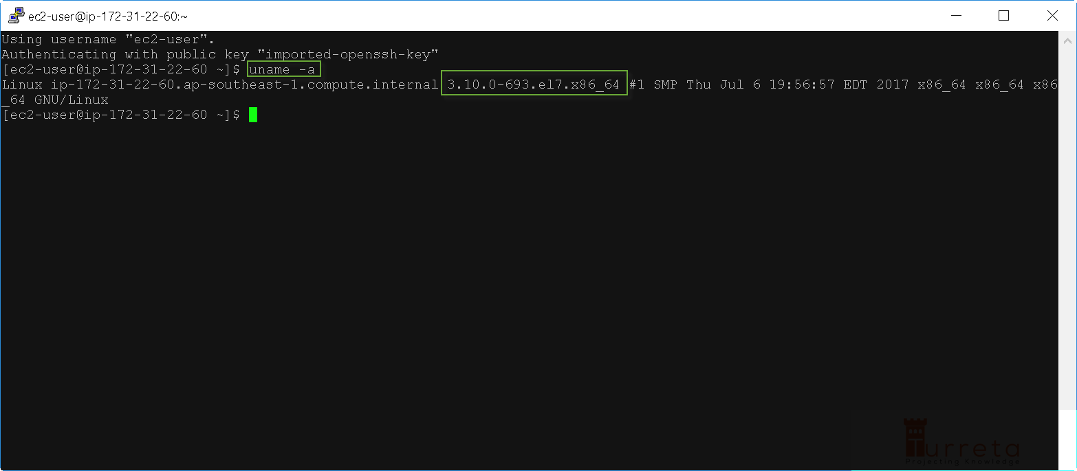

**2. Update yum**

It is recommended to update our system. Use:

Shell



|  |  |
| --- | --- |
| 1 | sudo yum update |

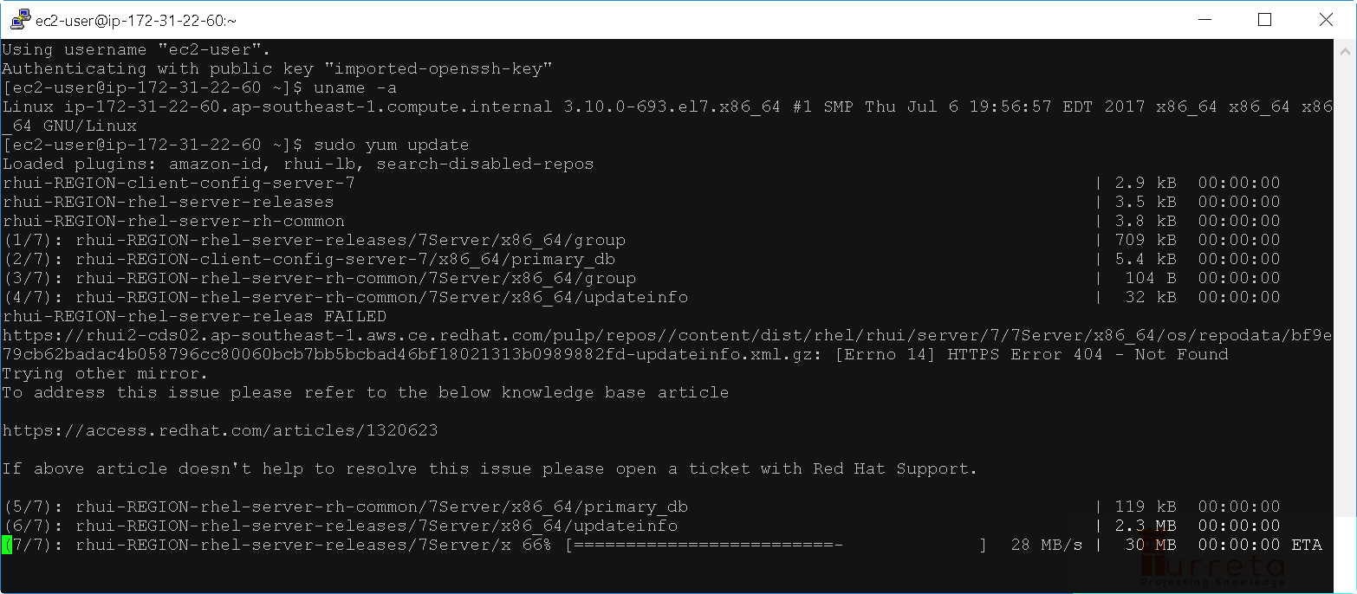

When YUM asks us for some confirmation about the total size of binaries to be downloaded, type yand press Enter to proceed.

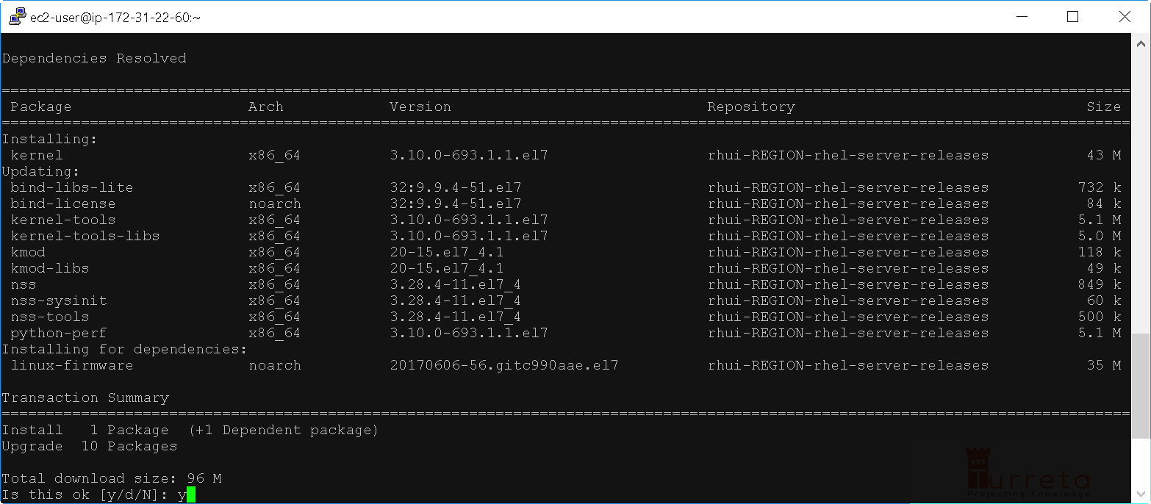

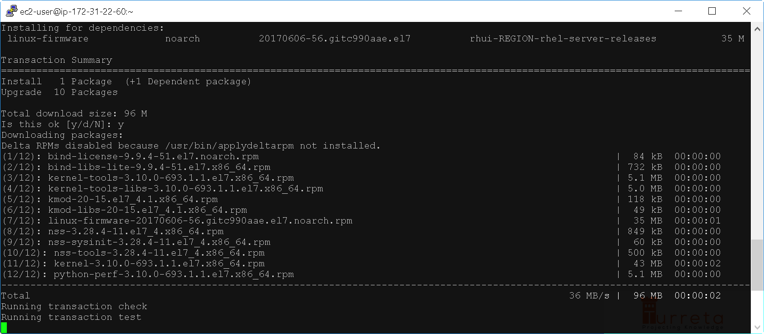

Installation completes!

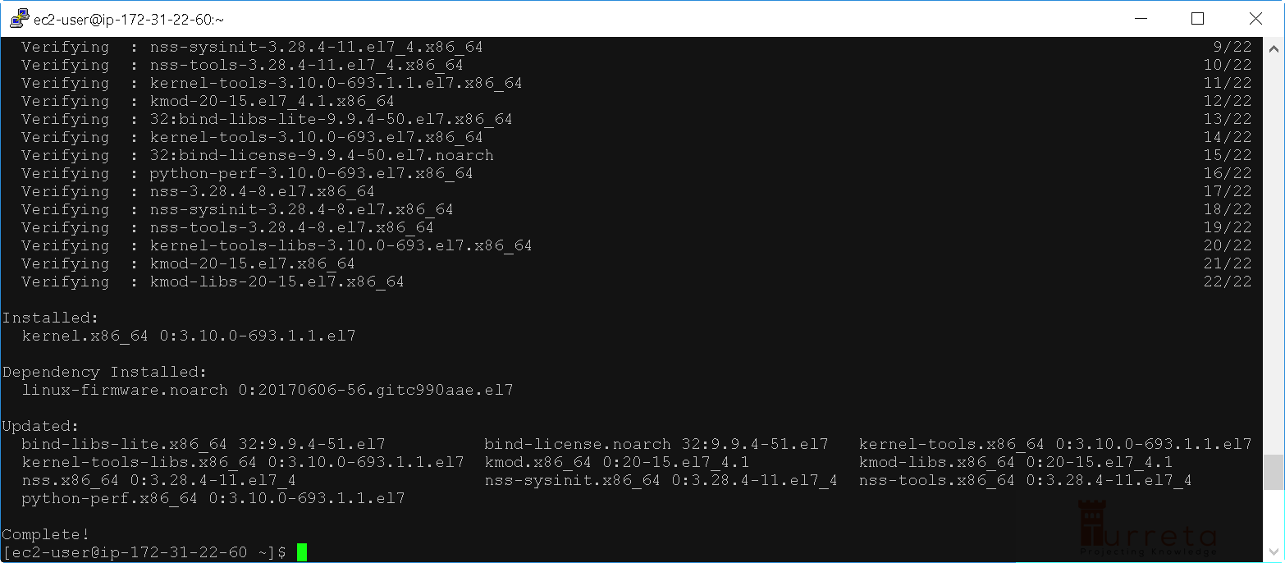

**3. Add Docker repository**

Use the following command:

Shell



|  |  |
| --- | --- |
| 1  2  3  4  5  6  7  8 | sudo tee /etc/yum.repos.d/docker.repo <<-'EOF'  [dockerrepo]  name=Docker Repository  baseurl=https://yum.dockerproject.org/repo/main/centos/7/  enabled=1  gpgcheck=1  gpgkey=https://yum.dockerproject.org/gpg  EOF |

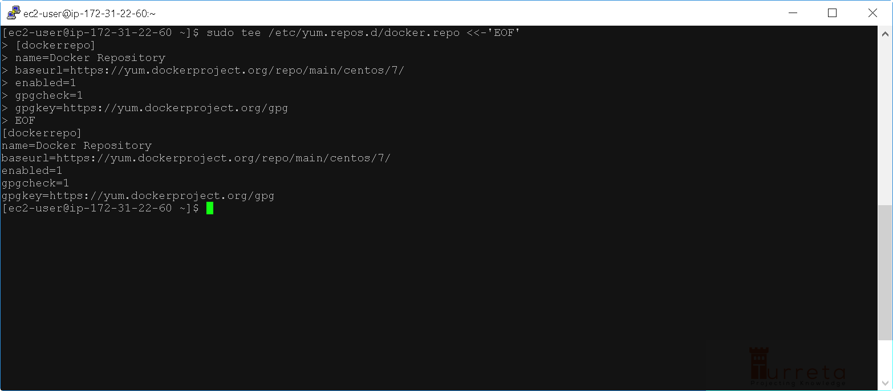

Notice the baseurl points to <https://yum.dockerproject.org/repo/main/centos/7/>

If we access the <https://yum.dockerproject.org/repo/main/centos/>, we get this page. Depending on our requirement, we have need to choose Docker binaries between two versions CentOS. For this post, we use version 7.

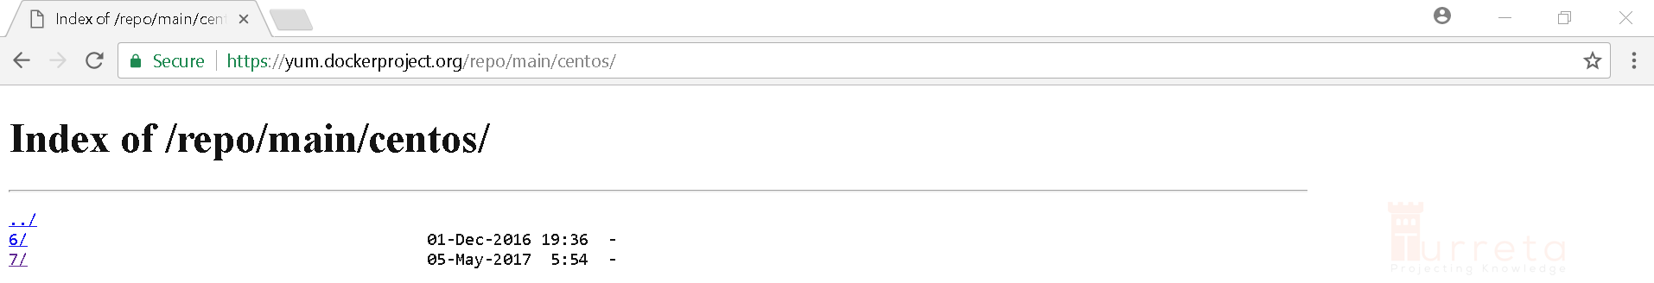

**4. Install Docker Engine**

Then we install docker-engine.

Shell



|  |  |
| --- | --- |
| 1 | sudo yum install docker-engine |

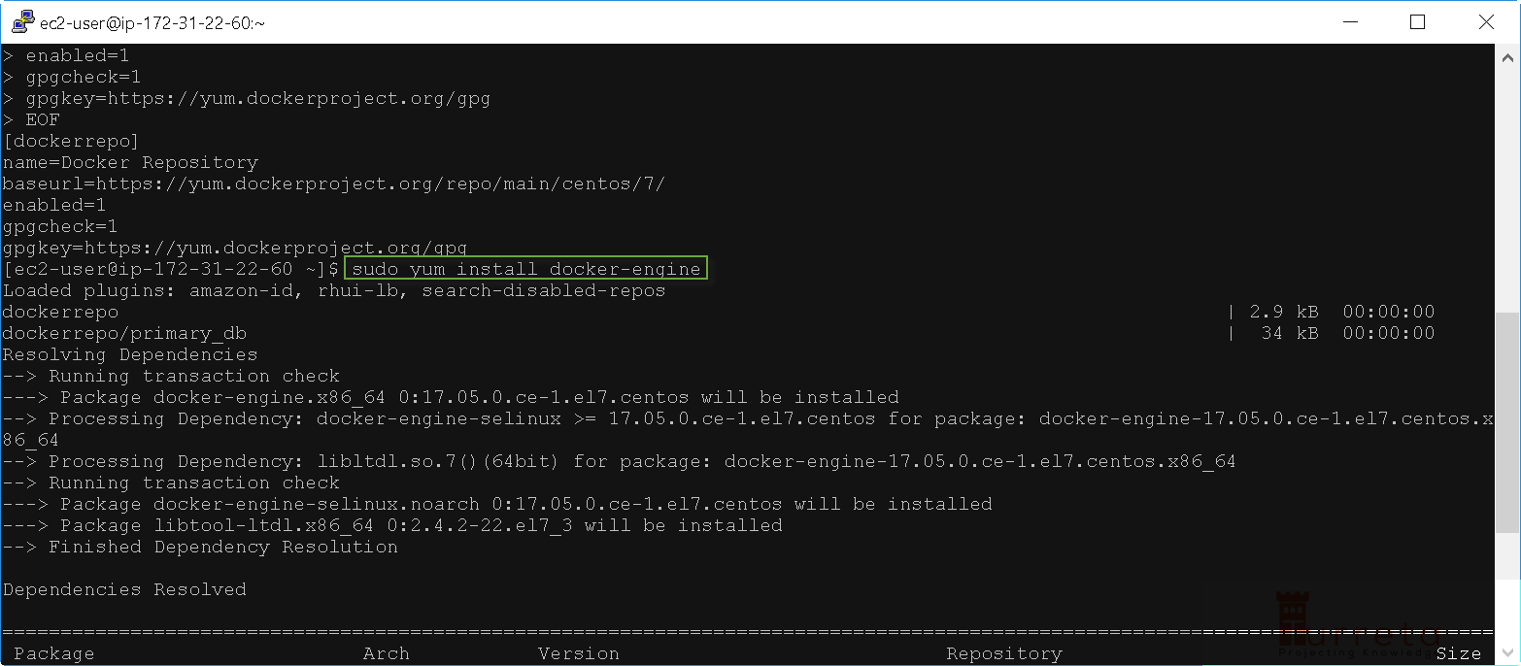

Type y and press Enter to proceed.

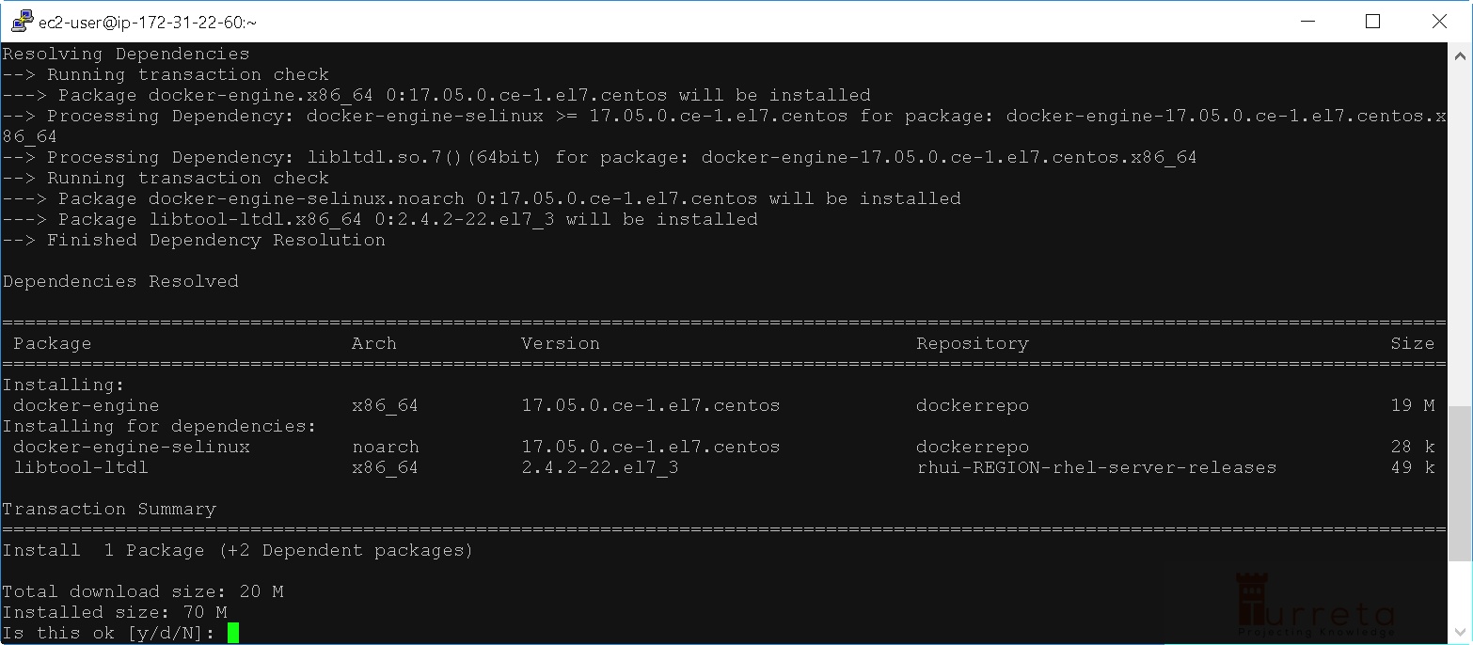

Type y and press Enter to proceed, again.

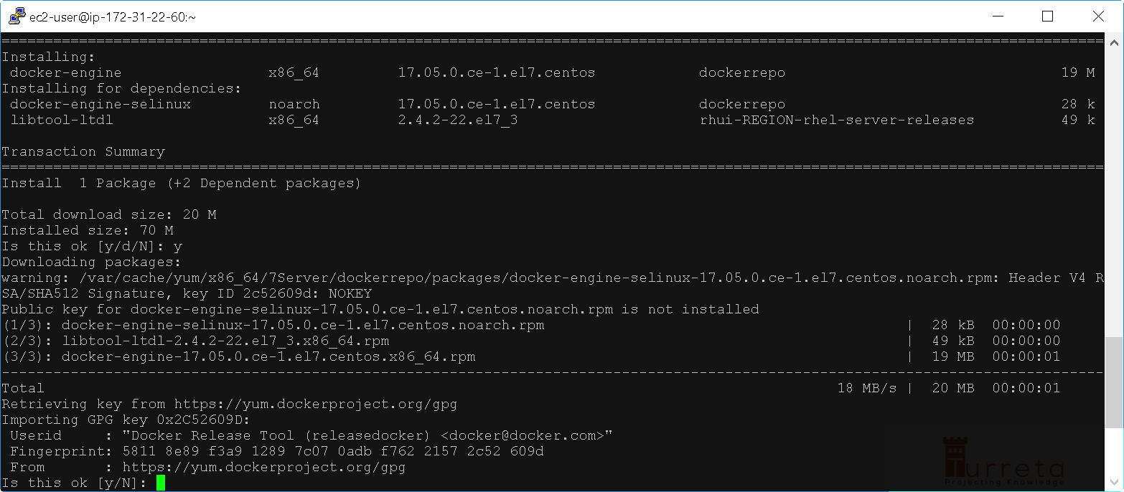

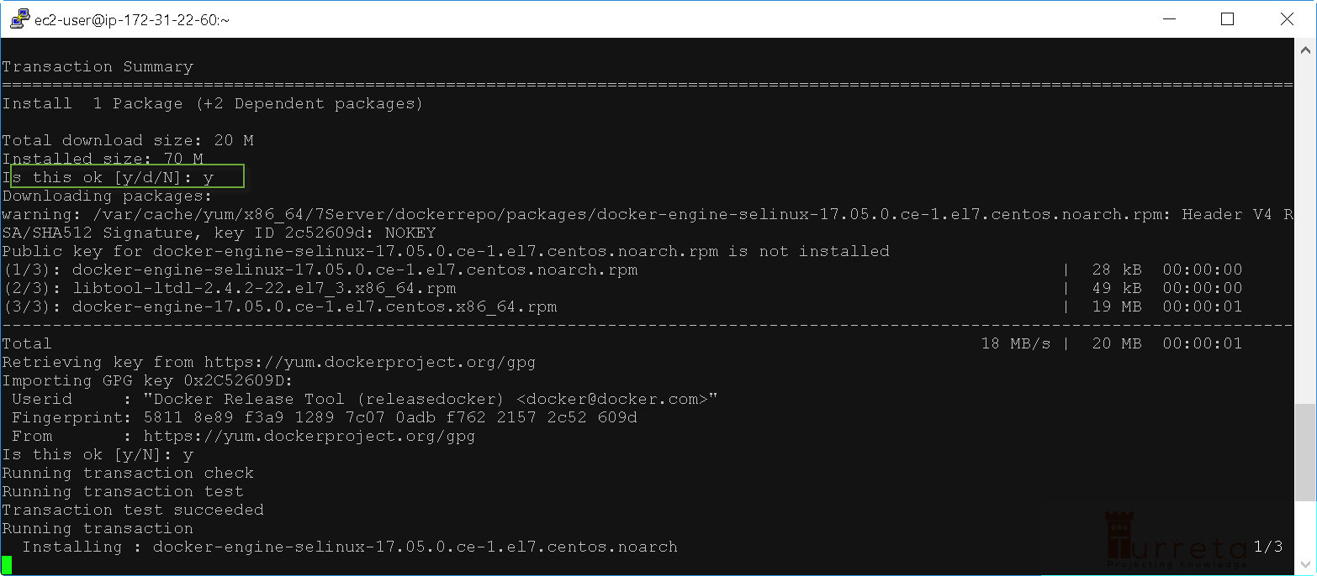

docker-engine installation completes.

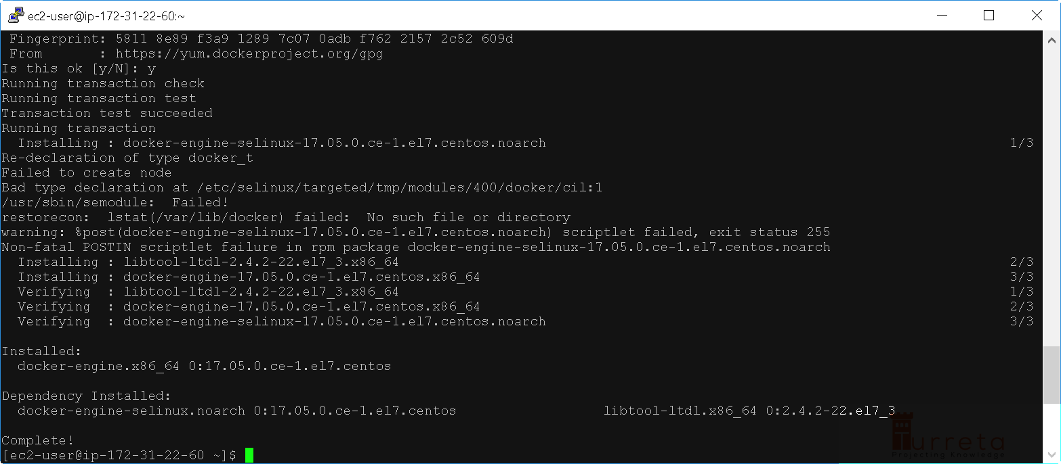

**5. Enable Docker Service**

Use the following command:

Shell



|  |  |
| --- | --- |
| 1 | sudo systemctl enable docker.service |

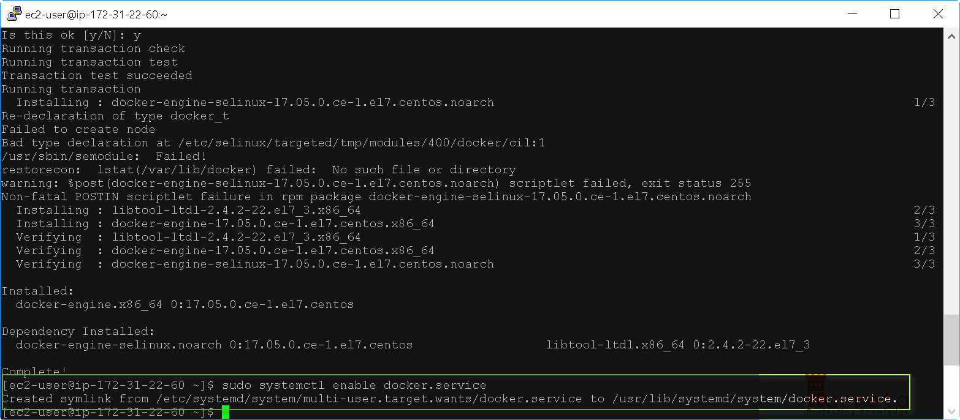

**6. Start Docker**

Use the following command:

Shell



|  |  |
| --- | --- |
| 1 | sudo systemctl start docker |

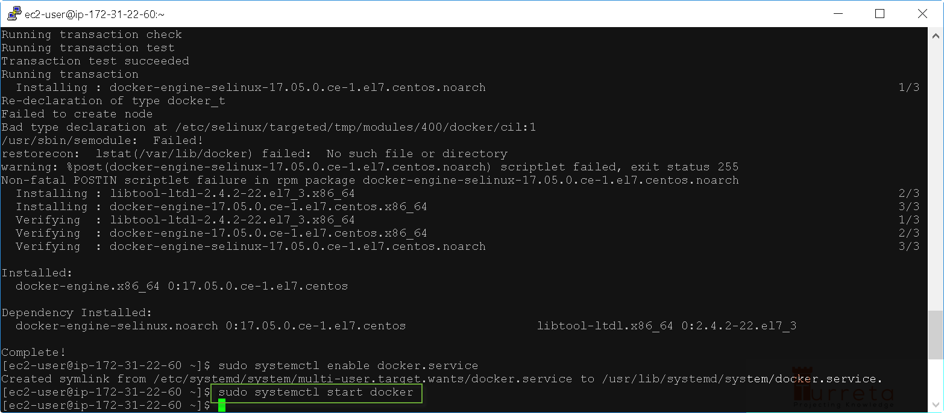

**7. Verify Docker is Running**

Use the following command:

Shell



|  |  |
| --- | --- |
| 1 | ps -ef | grep docker |

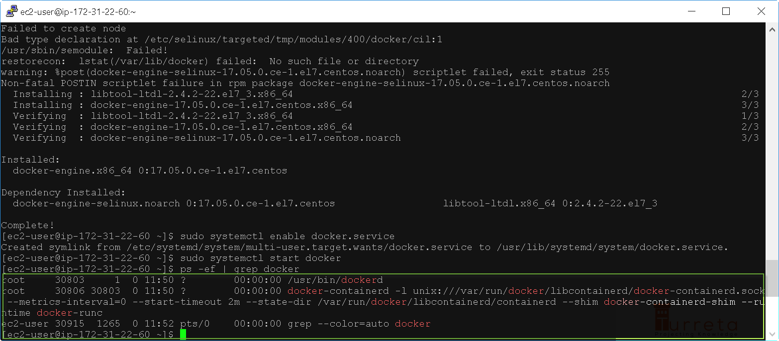

<https://turreta.com/2017/08/17/install-docker-in-red-hat-enterprise-linux-and-aws-ec2/>